SANDRA NJUKI

[swambuinjuki@gmail.com](mailto:swambuinjuki@gmail.com)

POWER LEARN PROJECT

AI SAFARI CAMPS

ASSIGNMENT 1

Description

In this assignment, learners will **collaborate** to create an **AI-powered digital branding agency** using tools like **ChatGPT and Canva Magic Media**. They will go through **branding setup, content creation, and monetization strategies**, working towards a **marketable digital branding portfolio**.

**PHASE 1: Branding & Business Setup**

TASK 1

* **Business Name Idea**

**EchoVerse Branding**; – Future-ready brands, built today

* **TagLine**

Smart design. Smarter strategy.

* **Brand Mission**

Our mission is to empower startups and businesses with intelligent, AI-driven branding solutions that combine creativity, strategy, and technology. We aim to make professional branding accessible, scalable, and impactful in the digital-first world.

TASK 2:

**Brand Story**

At EchoVerse Branding, we believe that the future of business identity lies in the fusion of human creativity and artificial intelligence. Born from the vision of helping startups stand out in a crowded market, we use advanced AI tools to craft unique logos, captivating brand stories, and engaging marketing strategies. We don’t just design visuals, we design experiences that resonate with audiences and drive business growth. Our approach ensures that every brand we create is not only beautiful but also future-ready, scalable, and impactful.

TASK 3

**Canva Magic Media Logo**

<https://www.canva.com/design/DAGwWcjfXCs/6TszdJlFWof4dlwuIEBasQ/view?utm_content=DAGwWcjfXCs&utm_campaign=share_your_design&utm_medium=link2&utm_source=shareyourdesignpanel>

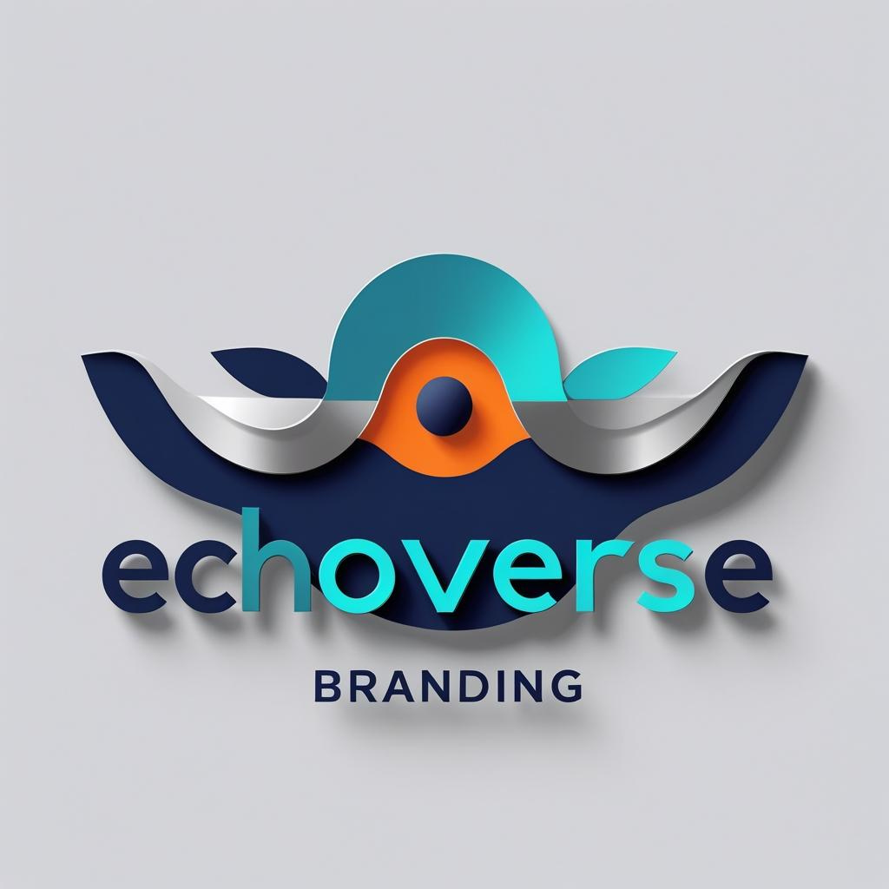

**Phase 2: AI-Generated Design & Marketing Content**

TASK 1:

**Engaging Social Media Post Ideas**

1. Your brand deserves more than a logo. With AI-powered branding, we give your business a voice, a story, and an identity. Let’s build the future together. DM us today!
2. Startups, it’s time to shine. Get your professional branding done with AI—fast, affordable, and futuristic. Click the link to begin your journey!
3. Imagine having a brand identity designed in hours, not weeks. That’s the power of AI branding. Ready to stand out? Let’s talk.
4. Logos fade. Stories last forever. We use AI to give your business a story that sticks. Book your free consultation today!
5. Stop blending in. Start standing out. AI-powered branding for bold businesses. Message us now to get started!

**AI Enhanced Graphics**

<https://www.canva.com/design/DAGwWZDLras/QaEQq0Th4jAofm8NgarpTQ/view?utm_content=DAGwWZDLras&utm_campaign=designshare&utm_medium=link2&utm_source=uniquelinks&utlId=h1af6c52d39>

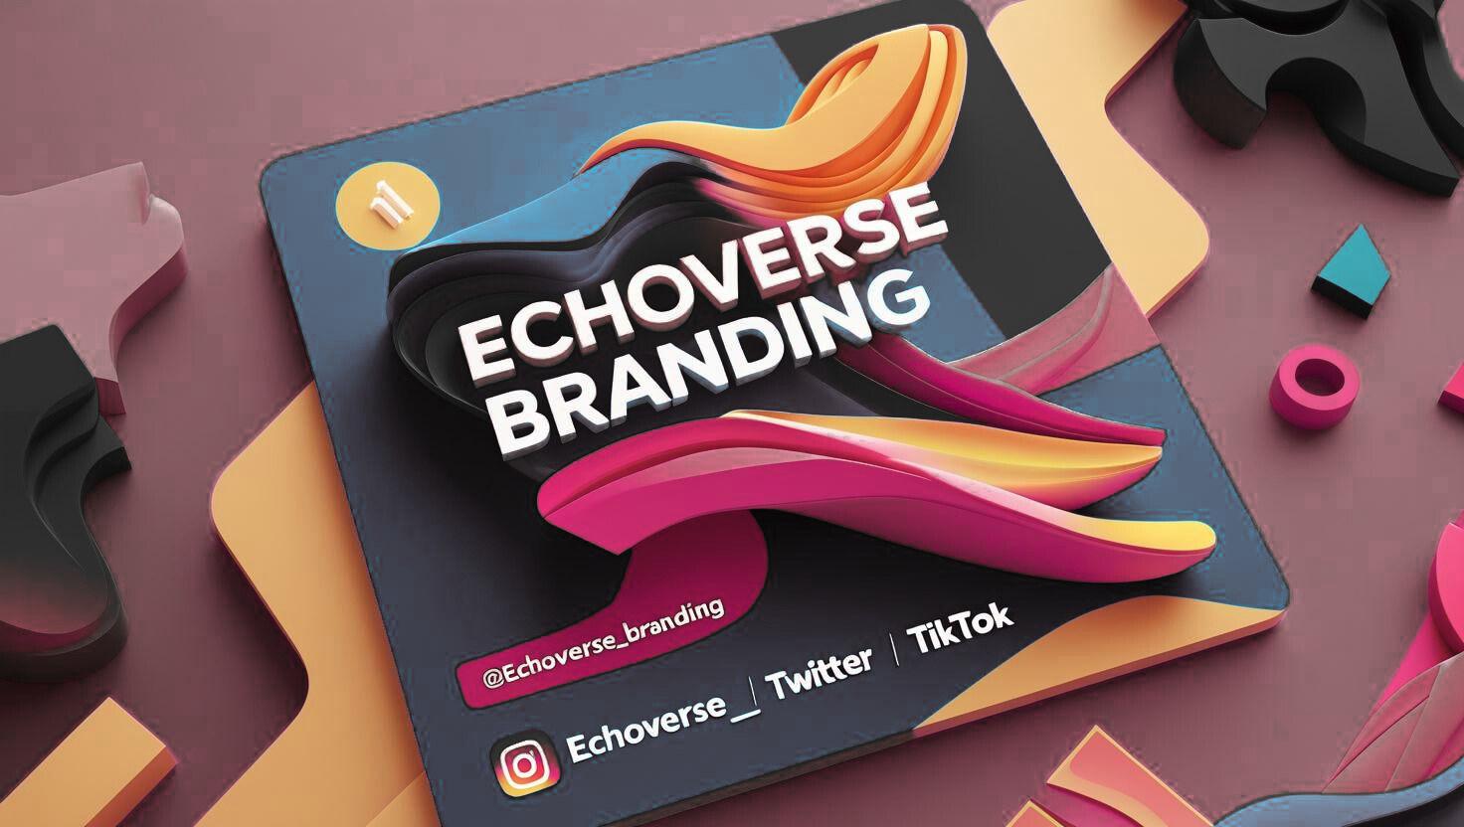

TASK 2:

**Sample Website**

[**https://github.com/sandranjuki/PLP-AI-SAFARI-CAMPS-MODULE-1-ASSIGNMENT-1/blob/main/echoverse.html**](https://github.com/sandranjuki/PLP-AI-SAFARI-CAMPS-MODULE-1-ASSIGNMENT-1/blob/main/echoverse.html)

TASK 3:

**Sample Marketing Copy:**

* **Ad Copy:**  
  Brand smarter, not harder. Our AI-powered branding services bring your vision to life with intelligent design, storytelling, and strategy.
* **Blog Intro:**  
  In today’s digital-first world, your brand identity is everything. Discover how AI is reshaping branding making it faster, smarter, and more affordable for startups.
* **Product Description:**  
  AI Branding Package; Includes custom AI-generated logo, social media kit, and brand story tailored to your business needs*.*

**Phase 3: Client Outreach & Monetization**

Task 1:

**Monetization Strategies:**

* **Brand Packages:** Tiered services (Basic: Logo + Story, Pro: Logo + Social Kit, Premium: Full Branding).
* **Subscription Model:** Monthly content & branding updates.
* **Freelance Marketplaces:** Offer services on Fiverr, Upwork, LinkedIn.
* **Partnerships:** Collaborate with web developers & social media managers.
* **Workshops:** Train small businesses on DIY AI-branding with consultation fees

TASK 2:

**Sales Pitch Email:**

*Subject:* Elevate Your Brand with AI-Powered Design

*Hello [Client’s Name],*

I hope this message finds you well. I wanted to share an exciting opportunity for your business to stand out in today’s competitive market. At **EchoVerse Branding**, we combine creativity with artificial intelligence to deliver professional branding that is fast, affordable, and impactful.

Whether you need a logo, social media content, or a complete brand identity, our AI-driven solutions are tailored to help you attract more customers and grow your business.

I’d love to schedule a short call this week to discuss how we can elevate your brand presence. When would be a good time for you?

Warm regards,  
[Your Name]  
EchoVerse Branding – Future-ready brands, built today*.*

TASK 3:

**Canva Pitch Deck**

<https://www.canva.com/design/DAGwWXMseng/KRwdECmtJPq1nq5ibY6QBA/edit?utm_content=DAGwWXMseng&utm_campaign=designshare&utm_medium=link2&utm_source=sharebutton>